Title (Times New Roman Bold, 14 pts)
Author ^{1*}, Author ¹ and Author ² (Times New Roman, 12 pts)
¹ Address author 1…
² Address author 3, (Times New Roman, italic 12 pts)
*email@my.mail.com

Abstract:
Abstract must be written in Times New Roman 12 pts, justified, no more 150 words.

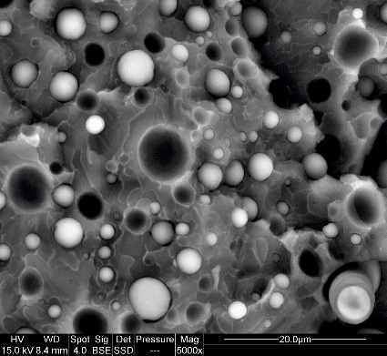
Figure 1: SEM Analysis

References
1- Names, Title, Journal, Year, Volume (Issue) Pages

